**实验内容：**

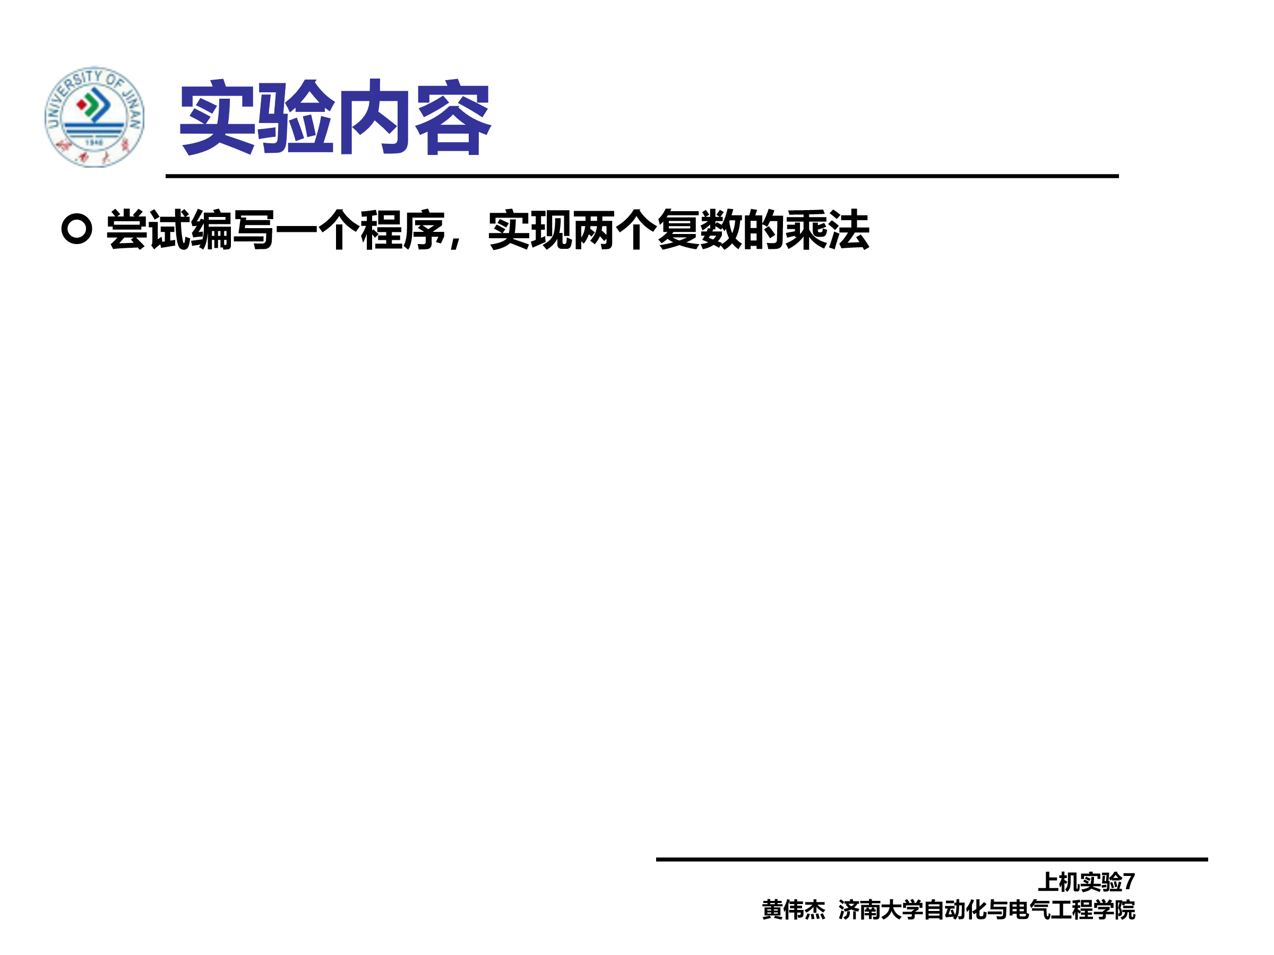

**程序：**

#include<iostream>

using namespace std;

class Complex {

public:

double real;

double imag;

Complex(double r = 0, double i = 0)

{

real = r; imag = i;

}

};

Complex operator*(Complex co1, Complex co2)

{

Complex temp;

temp.real = co1.real * co2.real - co1.imag * co2.imag;

temp.imag = co1.imag * co2.real + co2.imag * co1.real;

return temp;

}

int main()

{

cout << "请分别输入两个复数的实部和虚部。" << endl;

double x[2], y[2];

cin >> x[0] >> y[0] >> x[1] >> y[1];

Complex com1(x[0], y[0]), com2(x[1], y[1]), total;

total = com1 * com2;

cout << "com1(1.1, 2.2) * com2(3.3, 4.4) = real（" << total.real << " " << "）+ imag（" << total.imag << "）" << endl;

return 0;

}

**运行结果：**

